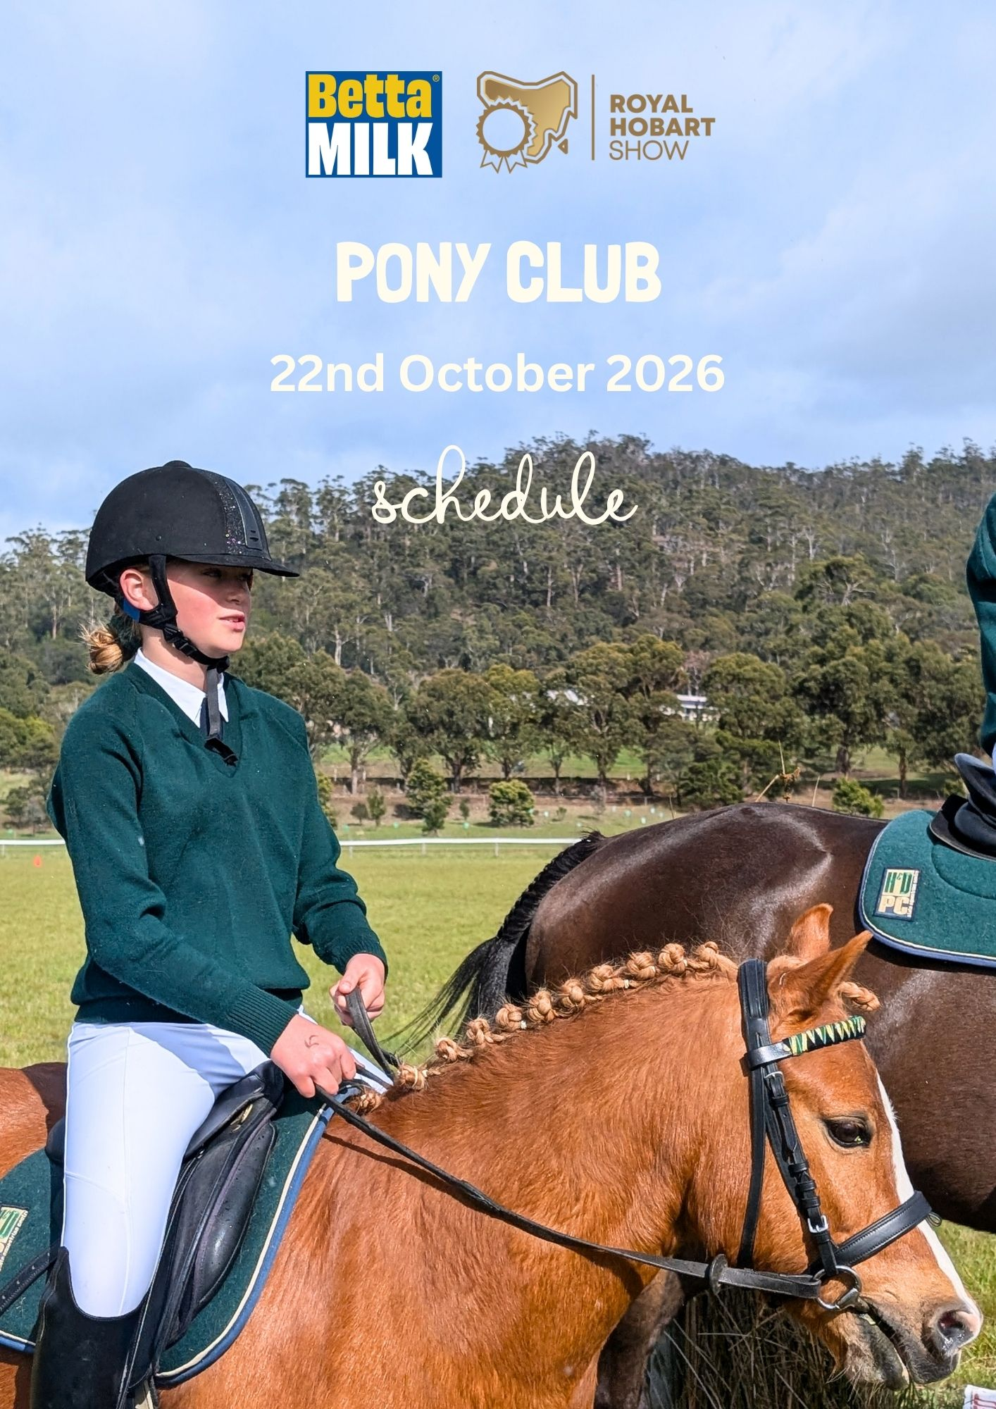


Contents
IMPORTANT INFORMATION…………………………………………………….2
EXHIBIT INFORMATION.…………………………………………………………3
TROPHIES AND SPECIAL AWARDS …………………………………………..4

SPONSORS ……………………………………………………….…………….…5

SHOW REGULATIONS ………………………..…………………………………6
SCHEDULE …………………………………………………………………………


PARTICIPANT WAIVER…………………………………………………………….
https://tinyurl.com/HobartShowEquestrian

www.hobartshowground.com.au

verity@hobartshowground.com.au

03 6272 6812

Entry fees | Team - $28 Per Team/Class  Classes - $8 Per Class  If entering 2026 Equestrian Classes, the below discounted pricing applies:  RAST Full Members - $9 per class  Non-Members - $14 per class  Pony Club uniform can be worn in Equestrian classes.
Entry | Enter Online  https://entries.hobartshowground.com.au/Home
Closing DATE | Midnight Sunday 4th October 2026  No late entries or entries on the day accepted
Location | Tasmanian Equestrian Centre  Equestrian Dr, Lauderdale, TAS  https://www.tas.equestrian.org.au/content/about-tec
prize money | There will be NO prize money for Pony Club classes.  Champion & Reserve Champion  Every Champion and Reserve Champion will receive a family pass to the show at the Regatta grounds.
judging  Classes commence at  8.30am each day  Judges’ names will be advertised prior to show | Thursday 22nd October 2026  Classes will NOT be held up for competitors entered in multiple rings.  Exhibitors enter classes in more than one section at their own risk.
Show Jumping | Jumping Tasmania South will be running a Royal Hobart Show Showjumping event Saturday 24th and Sunday 25th of October.  To enter via this link: https://www.nominate.com.au/equestdn/Nominate.aspx
IMPORTANT INFORMATION
EQUESTRIAN COMMITTEE
David Beard (Chair)
Erica Clark (Deputy Chair)
Russell Cripps
Jess Halton – Pony Club
Wendy Cotton – Pony Club
 | EXHIBIT INFORMATION
Parking & Camping | Parking will be available on site. Please follow signage to the correct area upon arrival. A map will also be provided with your acceptance of entries.  Limited camping is available. If you would like to access this, book when completing entries. Powered camping $15 per night, Per competitor. Non powered camping $10 per night. Per competitor.  To book visit:  https://nominate.com.au/stables/Venueintroduction.aspx
FOOD on site | A Food and Coffee van will be available on site.
Yard hire | Yards are available for $15 per yard, book when completing entries. Yards are to be left free of manure, rubbish, and hay. To book visit:  https://nominate.com.au/stables/Venueintroduction.aspx
Social Media | Up to date information about this event will be posted on the Royal Hobart Show Equestrian Facebook page https://tinyurl.com/HobartShowEquestrian  Or on the Hobart Showground Facebook page https://www.facebook.com/HobartShowground/
Photographer | ESP Photography
course designer | Tim Williams

TROPHIES AND SPECIAL AWARDS

** All perpetual trophies are engraved with the winner’s details and retained in the offices of the Society **

CHARLTON SHIELD
Awarded to the pony club with the highest overall score in the pony club team events.
2025 Winner: Huon District Pony & Riding Club

SUPREME PONY CLUB HORSE
Open to Champion PC Small Pony, Large Pony, Galloway and Hack.
2025 Winner: Maggie Blight

SUPREME PONY CLUB RIDER.
Open to Champion Junior, Senior and Open Riders
2025 Winner: Grace Jones

CHAMPION PONY CLUB SHOWJUMPER
Winner receives the Society’s rosette, plinth, Yaleena Bridges photography voucher $100 Equestrian Collective gift card.
2025 Winner: Lilly Mace

Animal Welfare Award
Awarded to a rider that is in the judge’s opinion have a harmonious relationship between horse and rider, connection between horse and rider and competent handling in all situations.
2025 Winner: Eva Sommerville

SPONSORS
The RAST gratefully acknowledges the following sponsors.






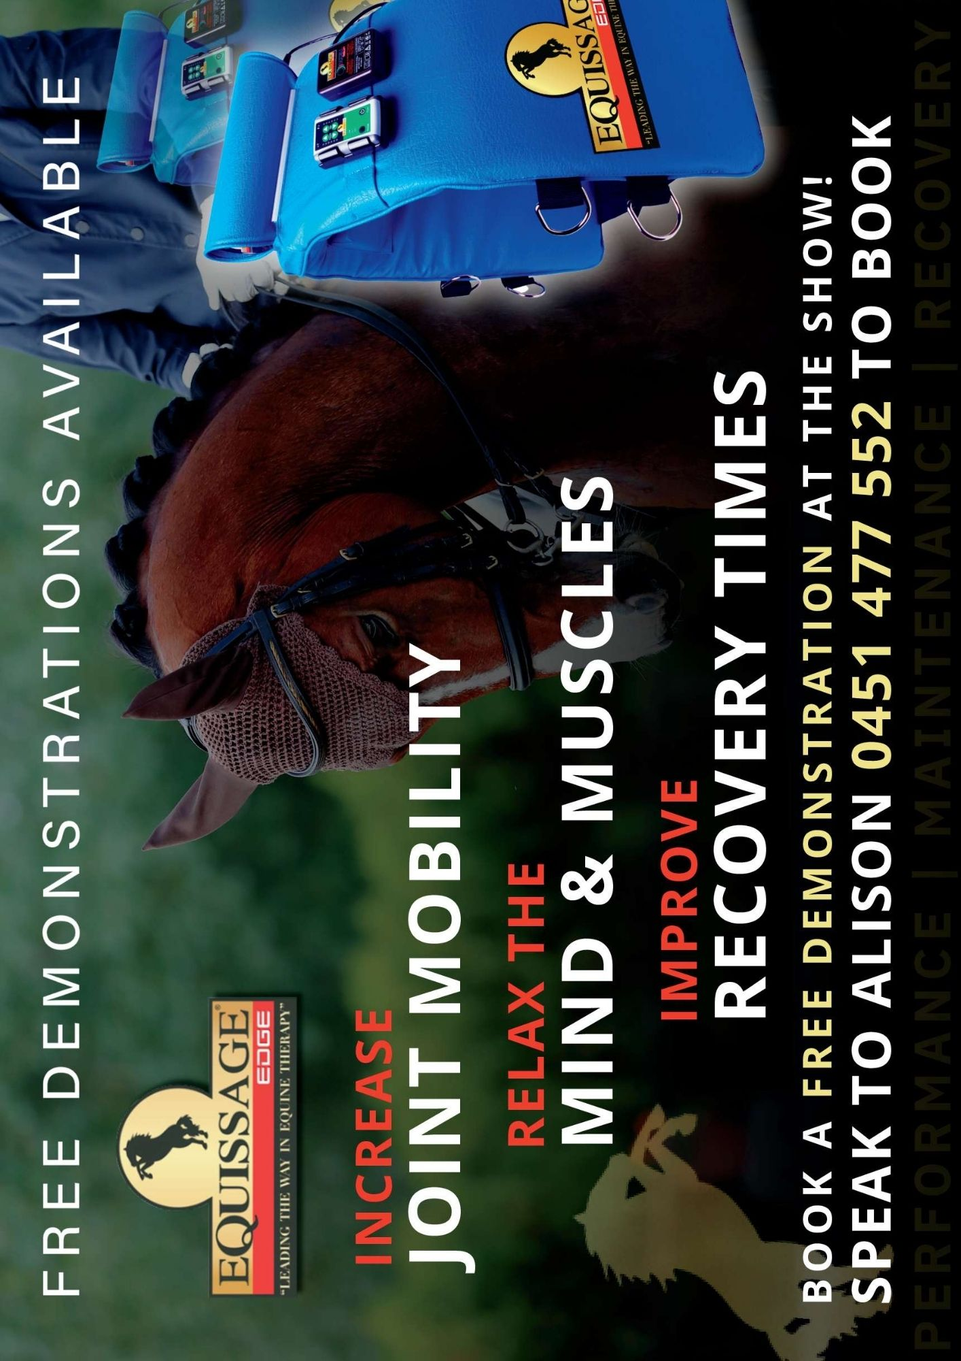
Beard Family
Note: Not all sponsorship confirmed at the time of schedule release

GENERAL REGULATIONS

CONDITIONS OF ENTRY
By entering this competition, exhibitors agree to comply with these terms and conditions and the rules, regulations and policies of the RAST (‘Rules’). Upon submission of an entry, the exhibitor agrees to be bound by the Rules and to ensure that his or her family, invitees and agents also comply with the Rules and follow all directions of Ground Staff during the competition.
The Royal Agricultural Society of Tasmania (‘RAST’ or ‘Society’) reserves the right to accept or reject any entry without assigning any reason. Exhibitors entering their horses do so entirely at their own risk, and it is a condition of entry that no liability of any kind attaches itself to the Society, its Council Officers, Officials or Members in any respect whatsoever, other than the liability for refund of entry fees in the event of abandonment of any competition.
Where an exhibit, exhibitor and/or an agent fails to comply with any of the Rules, RAST may impose one or more of the following penalties on them: (d) disqualification; (e) suspension; (f) a fine; (g) order the exhibit or the exhibitor, his or her family, invitees and agents be removed from the showgrounds; or (h) any other penalty. Without limiting the above, RAST may forfeit an award.
COMBINING OF CLASSES
Should special circumstances arise, the RAST reserves the right to combine classes, vary conditions and alter classes as it sees fit. The judge will also have the right to transfer entries from one class to another.
SUBSTITUTION OF HORSES
Riders are to be aware of the following EA regulation:
EA General Regulations Article 116.8 – an athlete may withdraw any or all of his/her horses from a competition, but may not add a horse that had not previously been entered for that competition without the approval of the Organising Committee or the Ground Jury.
MEMBERSHIP ELIGIBILITY
Exhibitors entering in PONY CLUB Classes must be a current financial member of their nominated club and have current PCAT insurance.
RIDER AGE – all classes
Age of rider is as at 1st January in the year of competition as per PCT rules.
PROTESTS
Protests may only be made by exhibitors with exhibits in the class to which the protest relates. Exhibitors may enter a protest by lodging it in writing at the RAST site office within 1 HOUR of the completion of the event to which the protest relates. Protests must be accompanied by a deposit of $50. The RAST Rules and Protest Committee will consider the protest as soon as practicable and will advise the exhibitor of its decision. If a protest is upheld, the deposit will be returned to the exhibitor. The decision of this committee is final.
JUDGE'S AUTHORITY
Judges may send off a horse which, in their opinion, is unfit to be entered in the class being judged.
Exhibitors are not to approach any judge without prior approval from that judge’s steward, the Chief Steward or the Ringmaster, except as required by the judge during the conduct of a class.
ACCEPTABLE ATTIRE
Riders must present in full Formal Pony Club Uniform for the club they are representing, including correct Club Saddle Blanket. Horses are to be plaited as per official PC event requirements.
SADDLERY
All saddlery and gear must be suitable, safe and properly fitted.
Bearing reins, balance reins, draw reins, running reins or similar devices are not permitted at any time on any part of the competition grounds.
SWABBING
Random swabbing may be undertaken during the show, conducted in accordance with RAST requirements. It is a condition of entry you comply with any swabbing request.
SUBSTITUTION OF HORSES
An exhibitor may withdraw any or all of their horses from a competition but may not add a horse that had not previously been entered for that competition without the approval of the Committee.
HORSE CONTROL
Any horse which in the opinion of the Chief Steward is not under adequate control will be sent off the arena.
No STALLIONS permitted on Pony Club Day as per PCT ruling.
REFUNDS
Entry fees will not be refunded other than in exceptional cases and where a veterinary certificate is supplied. A refund, less 25% administration fee, will be at the discretion of the Equestrian Committee. All applications under these conditions must be received at the RAST office by Tuesday of the week following the Royal Hobart Show. This ruling will not apply where entries are not accepted by the RAST.
PLACINGS
RAST ribbons will be awarded as follows, at the Judge’s discretion, for placings in individual classes: 1st - Blue, 2nd - Red, 3rd - White, 4th - Yellow
All first place winners are eligible for the relevant Champion award within their section, unless otherwise stated in the class listings. At the Judge’s discretion, the exhibit that is placed second to the selected Champion in its qualifying class is may be eligible to be considered for Reserve Champion.
HORSE AGE
The age of horses is to date from 1 August in each year. Every horse foaled before 1 August in any year shall be deemed to be one year old on that date.
MANURE
All manure is to be picked up from horse area and yards. Failure to do so may result in a fine to the exhibitor.
HORSES ON THE ARENA
Only those horses competing on the day are permitted on the arena while events are underway.
CLASHING CLASSES
Some classes may be run concurrently and may clash. Due to time restrictions on the day we may not be able to accommodate for clashing classes.

DEFINITIONS
Novice: Open to all horses in that height section. Not to have won First Place at any Agricultural Show
Open: Open to all horses in that height section. Competitors may enter in either Open Show horse OR Open Hunter horse, not both.
Master: Horse has been retired from racing prior to October 2024 (over 2 years)
Newcomer: Open to horses retired from racing since October 2024 (2 years and under)
Pleasure: For all horses in that height section, snaffle bit only.
Pony Club Versatility: For all horses in that height section
TOPSY
Topsy Classes are open for riders 12 years or under, Walk-Trot only and are designed for Pre-Novice riders.
Topsy riders must be in Pony Club Uniform and Leaders to be in Club Uniform or neat casual. Any rider in Topsy Classes will not be eligible to enter any other classes in the open ring.
LEADING REIN
8 years and under. Snaffle bridle only. Attendant must affix the leading rein to the noseband, the reins should go directly to the child’s hand, string not permitted, or any aid fastened to the saddle to keep the pony’s head in position. No spurs or whips, handler may carry a cane. Riders should at least be able to rise to the trot. Ponies must not exceed 12hh.
DOGS Dogs are not permitted. This will be strictly enforced.
OFF THE TRACK SERIES
Open to all registered Thoroughbred and Standardbred exhibits that were bred for racing, or have raced, or barrier trialled. Race name must be supplied on entry together with ASB Numbers. Documentation verifying eligibility must be provided on request. Stallions not eligible.
ANIMAL WELFARE
No cruelty will be tolerated. Exhibitors must familiarise themselves with the RAST policies which can be found at https://www.hobartshowground.com.au/policies
COLLECTION & USE OF PERSONAL INFORMATION
The Society collects personal information from exhibitors in competitions conducted by the Society. Verification of the accuracy of this data may be obtained through contact with the RAST. This information is used only for the purpose related to the conduct of the events run by the Society and is not divulged to third parties. However, entrant’s names and contact details may be released to duly authorised parties in respect to matters of animal health and safety. The names of exhibitors may be included in catalogues published by the Society and successful exhibitors’ names released for general publication. If you do not provide the information requested on the competition entry form, we may not be able to accept your entry.

GAMES
Below are the games that will be played in Class PC3 and points can be used towards the Charlton shield. DC’s must nominate games or show jump team for Charlton shield.
- Bending
- Ball and Bucket
- 5 Flag

- Sword
- 2 Mug
- Rope
- Charlton race

SHIELD CLASSES

DC to enter teams - Clubs may enter more than one team, however, 1 team per club per section to be nominated by 8.30am show morning

PLEASE NOMIATE GAMES OR SHOW JUMP TEAM FOR CHARLTON SHIELD

Games will be running concurrently with Team Show Jumping.
Class PC1 TEAM RIDING for teams of 3 - points awarded for Charlton Shield
Class PC2 TEAM JUMPING & Pony Club Champion Jumping Rider
Class PCS101 CHAMPION PONY CLUB SHOWJUMPER Champion - Highest Score Rider from PC Teams event.
Class PC3 TEAM GAMES - points awarded for Charlton Shield
Class PCS100 CHARLTON SHIELD - Awarded to Highest Scoring Pony Club. Scored from class PC1 and/or PC2 or PC3 on a 3, 2, 1 points basis. Awarded at the conclusion of these classes.
PONY CLUB EVENTS

Hacking to commence at conclusion of Team Show Jumping/Games and concurrently with Individual Show Jumping Classes
HACKS
Class PCH1 Smartest Hack on Parade (not eligible for Champion)
Class PCH2 Novice Hack
Class PCH3 Open Show Hack
Class PCH4 Open Show Hunter
Class PCH5 Best Educated
Class PCH6 Pony Club - Versatility Class
Class PCH7 Pair of PC Hacks (not eligible for Champion)
Class PCHS1 Champion Hack
Class PCHS2 Reserve Champion Hack

GALLOWAYS
Class PCG1 Smartest Galloway on Parade (not eligible for Champion)
Class PCG2 Novice Galloway
Class PCG3 Open Show Galloway
Class PCG4 Open Hunter Galloway
Class PCG5 Best Educated
Class PCG6 Pony Club - Versatility Class
Class PCG7 Pair PC Galloways (not eligible for Champion)
Class PCGS1 Champion Galloway
Class PCGS2 Reserve Champion Galloway
PONIES
Class PCP1 Smartest Large Pony on Parade (not eligible for Champion)
Class PCP2 Novice Pony
Class PCP3 Open Show Pony 12.2hh and under
Class PCP4 Open Pony Over 12.2hh
Class PCP5 Hunter Pony
Class PCP6 Best Educated
Class PCP7 Pony Club - Versatility Class Pleasure Pony
Class PCP8 Pair PC Ponies (not eligible for Champion)
Class PCPS1 CHAMPION SMALL PONY
Class PCPS2 RESERVE CHAMPION SMALL PONY
Class PCPS3 CHAMPION LARGE PONY
Class PCPS4 RESERVE CHAMPION LARGE PONY
LEAD REIN
Class PCLR1 Smartest on parade (not eligible for Champion)
Class PCLR2 Happiest Combination
Class PCLR3 Best Walk
Class PCLR4 Best Rising Trot
Class PCLR5 Best Hands
Class PCLR6 Best Combination
Class PCLR7 Best Seat
Class PCLRS1 CHAMPION LEAD REIN
Class PCLRS2 RESERVE CHAMPION LEAD REIN

TOPSY CLASS
Topsy Classes are open for riders 12 years or under, Walk-Trot only and are designed for Pre-Novice riders.
Topsy riders must be in Pony Club Uniform and Leaders to be in Club Uniform or neat casual. Any rider in Topsy Classes will not be eligible to enter any other classes in the open ring.
Class PCT1 Smartest on parade (not eligible for champion)
Class PCT2 Happiest combination
Class PCT3 Best Walk
Class PCT4 Best Rising Trot
Class PCT5 Best Hands
Class PCT6 Best Combination
Class PCT7 Best Seat
Class PCTS1 CHAMPION TOPSY
Class PCTS2 RESERVE CHAMPION YOPSY

OFF THE TRACK
PONY CLUB HORSE

Judged at conclusion of Hacking Classes.

Open to all registered Thoroughbred and Standardbred exhibits who were bred for racing, or have raced, or barrier trialled. Race name must be supplied on entry together with Microchip Numbers. Documentation verifying eligibility must be provided on request. Stallions not eligible.
Master OTT: Horse has retired from racing prior to October 2024 (over 2 years)
Newcomer OTT: Open to horses retired from racing since October 2024 (2 years and under)

TasRacing OTT Animal Welfare Award: To be judged on the horse’s presentation and condition, along with the handler’s horsemanship, focusing on the harmony between horse and handler, their connection, and
the handler’s competence in managing various situations.
Prize: $ 100 Voucher

All entries are free for this section.

Champion: OTT ribbon & $100 Voucher
Reserve Champion: OTT ribbon & product voucher to value of $50

Class PCOTTM TASRACING OFF THE TRACK - MASTER PONY CLUB HORSE
Class PCOTTN TASRACING OFF THE TRACK - NEWCOMER PONY CLUB HORSE
SUPREME PONY CLUB HORSE
Supreme Pony Club Horse
From Champion Hack, Galloway and Pony
Supreme Ribbon & Rug

Off The Track - Supreme Pony Club Horse
Supreme Ribbon & Rug

PONY CLUB - RIDER CLASSES

To Commence following completion Supreme Pony Club horse

SENIOR RIDER
Class PCSR1 Novice Senior Rider
Class PCSR2 Best Hands
Class PCSR3 Rider 17 - 18 years
Class PCSR4 Rider 19 - 21 years
Class PCSR5 Rider 22 - 25 years
Class PCSR6 Pair PC Senior Riders
Class PCSRS1 CHAMPION SENIOR PC RIDER
Class PCSRS2 RESERVE CHAMPION SENIOR PC RIDER
INTERMEDIATE RIDER
Class PCIR1 Novice Intermediate Rider
Class PCIR2 Best Hands
Class PCIR3 Rider 12 - 14 years
Class PCIR4 Rider 15 - 16 years
Class PCIR5 Pair PC Intermediate Riders
Class PCIRS1 CHAMPION INTERMEDIATE RIDER
Class PCIRS2 RESERVE CHAMPION INTERMEDIATE PC RIDER

JUNIOR RIDER
Class PCJR1 Novice Junior Rider
Class PCJR2 Best Hands
Class PCJR3 Rider under 10 years
Class PCJR4 Rider 10 years and under 12 years
Class PCJR5 Pair PC Junior Riders
Class PCJRS1 CHAMPION JUNIOR PC RIDER
Class PCJRS2 RESERVE CHAMPION JUNIOR PC RIDER
SUPREME PONY CLUB RIDER
Supreme Pony Club Rider
From Champion Senior, Intermediate and Junior.
PONY CLUB - JUMPING CLASSES

Individual showjumping will commence at conclusion of Team Jumping and will run concurrently with Hacking Classes.
Classes will not be held up and riders must jump in draw order.

Individual SJ Horse/Rider combination may enter 2 classes - plus the Pairs Jumping

Team Show Jumping Horse/Rider combinations may enter ONLY one individual SJ class and must be same

height or above the TEAM SJ height plus the Pairs Jumping. Teams Start at 80cm.

Class PCSJ1 95 cm Article 238.2.2
Class PCSJ2 1.05 Article 238.2.2
PTT Showjumping Class (open to all eligible OTT) - Start Height 85cm - Article 238.2.2
Class PCSJ3 65 cm One Round States - Article 238.2.1
Class PCSJ4 75 cm Article 238.2.2
Class PCSJ5 65 cm / 85 cm Odd & Evens - Pairs Jumping
Class PCSJ6 85 cm One Round Stakes 238.2.1

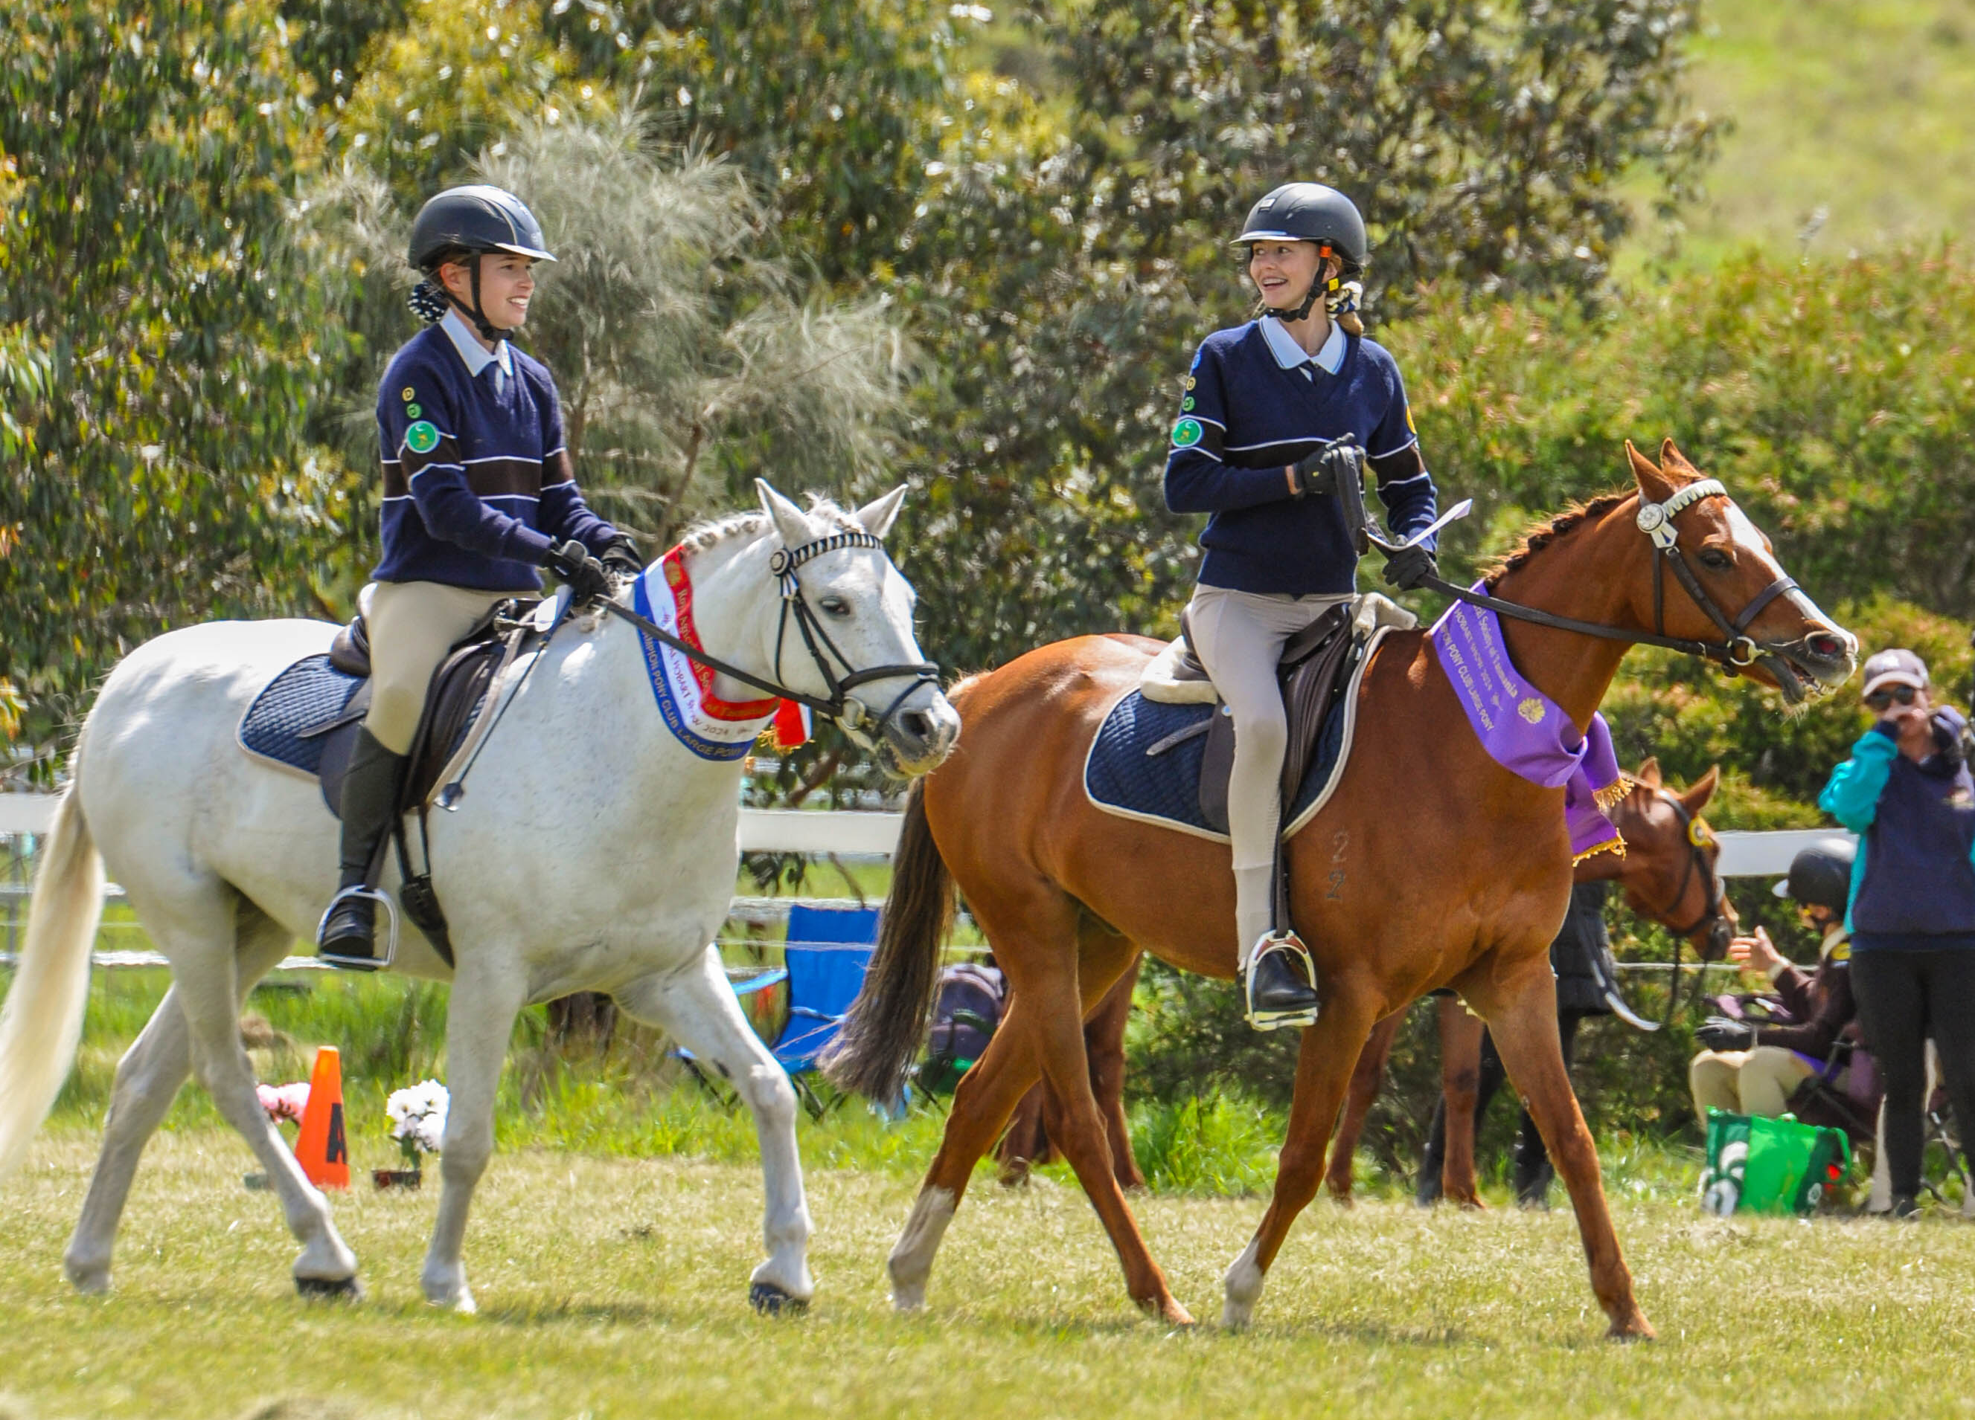

ROYAL AGRICULTURAL SOCIETY OF TASMANIA

THIS DOCUMENT IS A NO DUTY OF CARE RISK WARNING
THIS DOCUMENT IS A WAIVER OF DUTY OF CARE
Do not complete “Event” details if this document only applies to use of facilities other than for an Event.
Event Name (Subsequently referred to as “the Event”): ROYAL HOBART SHOW
Event Date: Thursday 22nd October 2026
Participant Name: Participant’s Date of Birth: _________
Participant Address: __________________________________________________________
Participant Contact Number: _________________
Participant Email: ______________________________
PLEASE COMPLETE DETAILS ABOVE: REFER TO SECTION F

Section A - Supplier’s statements about risk and duty of care
Royal Hobart Show (together the Suppliers) advise as set out below.
The handling of animals is a dangerous recreational activity as animals can act in a sudden and unpredictable way, especially when frightened or hurt.
Participation (including passive participation) in animal handling and/or physical competitions and/or Events at an agricultural show and/or use of the Suppliers’ facilities contain elements of risk, both obvious and inherent.
Physical competitions and activities, Events and use of the Suppliers’ facilities are all dangerous recreational activities.
This document is a risk warning for the purpose of Division 5 of the Civil Liability Act TAS 2002.
This risk warning is given by or on behalf of the Suppliers.
This document acts as an exclusion of liability under Division 5 of the Civil Liability Act (TAS) 2002 if the services supplied by the Suppliers are supplied without reasonable care and skill.

Section B - Participant’s acknowledgements
By signing this document I acknowledge that:
- Participation in the Event and/or use of the Suppliers’ facilities is a recreational service for the purposes of section 139A of the Australian Competition and Consumer Act (Cth) 2010 and a recreational activity for the purposes of Division 5 of the Civil Liability Act (TAS) 2002.
- I participate in the Event and/or use of the Suppliers’ facilities at my own risk.
- Participation in the Event and/or use of the Suppliers’ facilities is a hazardous activity and involves a significant risk of physical harm and may result in injury, loss, damage or death to me and others.
- Participation in the Event and/or use of the Suppliers’ facilities requires certain skills and experience. I declare that I have sufficient skills and experience to be able to safely and properly participate in the Event and/or use the Suppliers’ facilities.
- Animals can act in sudden and unpredictable ways, especially if frightened or hurt, or if exposed to loud or unfamiliar noises.
- The Event will be held in close proximity to rides and large groups of people and there may be loud and unfamiliar noises which can frighten animals used in the Event.
- If the Event is held outdoors, there are risks to me as a result of the weather conditions, including either extreme hot or cold weather, rain or wind.
- Insects or other animals may cause animals used in the Event to become frightened and act in an unpredictable way.
- In handling animals, there is a risk of suffering injury including injuries caused by the animals.
- I am responsible for ensuring that I have and will wear equipment suitable for my safety in my participation of the Event and/or in using the Suppliers’ facilities.
- I am responsible for the condition of any tools and equipment and ensuring that they are appropriate for the Event and/or in using the Suppliers’ facilities.
- I use the Suppliers’ facilities, including for the Event entirely at my own risk, as I find them and with the prior acceptance of the risk of possible danger to me, both obvious and inherent.
- At the time of participating in the Event and/or in using the Suppliers’ facilities, I will not to any degree be under the influence of alcohol or illicit drugs.
- I will not consume any alcohol or illicit drugs while participating in the Event and/or in using the Suppliers’ facilities and agree that such use may result in my being excluded from the Event and/or from using the Suppliers’ facilities with no entitlement to any refund of money paid to the Suppliers for entry.
- I agree to be bound by the rules and guidelines of the Suppliers as varied from time to time.

Section C - Participant’s acceptance of risk & no duty of care & waiver of rights
- I acknowledge and agree that my participation in the Event and any associated activities and/or my use of the Supplier’s facilities is dangerous and may have obvious and/or inherent risks as a result of which personal injury (and sometimes death) may occur.
- I acknowledge that my participation in the Event and any associated activities and/or my use of the Supplier’s facilities carry with them a significant risk of physical harm.
- I accept and assume all risks of personal injury or death in anyway whatsoever arising from my participation in the Event and any associated activities and/or my use of the Supplier’s facilities.
- I waive my individual right to sue the Suppliers for all claims I may have for such personal injury or death against the Suppliers in any way whatsoever arising from or in connection with my participation in the Event and any associated activities and/or my use of the Supplier’s facilities.
- If I suffer personal injury or death while participating in the Event and/or from my use of the Supplier’s facilities, I will not hold the Suppliers, their employees or agents legally responsible for any personal injury or death I suffer.
- I will not sue the Suppliers, their employees or agents for any claims, actions, costs, damages or liability.
- I release the Suppliers and their employees from legal responsibility for the services I have been provided and/or activity I have participated in, including the Event.

Section D – Signature (Please ignore and sign at Section F if using a Bulk Waiver)
Where the participant is 18 years of age or over:
I agree that I have read and understood this waiver prior to signing it.
I acknowledge that the Suppliers have permitted me to participate in the activity the subject of this document in reliance on the matters acknowledged by me and the representations I have made in this document.
I agree that this waiver is governed in all respects by and interpreted in accordance with the laws of Tasmania.
I agree that everything in this document is binding on me and my heirs, next of kin, executors and administrators.

Signature:........................................................... Dated: …………………………………………
Where participant is UNDER 18 years of age (to be completed by a parent or guardian):
Participant’s Date of Birth ..……………....……………………………………………………………….
I …................................................................................................................................ (insert parent/guardian name),
being a parent or legal guardian of the above named participant, hereby consent to my child using the Suppliers’ facilities and/or participating in the Event.
I confirm that I have read and understood and explained to the participant this waiver prior to signing it.
I acknowledge that the Suppliers have permitted the participant to participate in the activity the subject of this document in reliance on the matters acknowledged by me and the representations that I have made in this document.
I agree that this waiver is governed in all respects by and interpreted in accordance with the laws of Tasmania.
I agree that everything in this document is binding on me and my heirs, next of kin, executors and administrators.

Signature: ........................................................... Dated: …………………………………………

Section E - Horse Details and Acknowledgement

If there are no horses in this activity then leave this Section Blank. If there are horses in this event then this Section MUST BE COMPLETED.
Name of Horse | Owner’s Name | Microchip / Reg # or Description (Sex, Colour, Brand) | PIC No. | Last Event and Date | Signature and Date
I, the owner/rider/exhibitor of the above horse, declare that, to the best of my knowledge, it is fit and healthy and I agree that if found to be otherwise, it will not be allowed to compete at this event. If prior to the event, the health of the horse changes from the date of this declaration, I will inform the event organizer for their due consideration.

Version: January 2020
Section F – Bulk Signature Facility (if required)
  - I ACKNOWLEDGE THAT I HAVE READ AND UNDERSTOOD the above SECTIONS A through to D WARNING ME OF THE RISKS OF MY PARTICIPATION IN THE ACTIVITY
  - I HAVE MADE ALL FURTHER ENQUIRIES WHICH I FEEL ARE NECESSARY OR DESIRABLE AND FULLY UNDERSTAND THE RISKS INVOLVED IN THIS ACTIVITY
  - I SIGN THE DOCUMENT FREELY AND VOLUNTARILY WITHOUT ANY INDUCEMENT MADE TO ME

PARTICIPANT’S NAME  (Please Print) | PARTICIPANT  or PARENT/GUARDIAN’S  SIGNATURE | ADDRESS | EMAIL ADDRESS | DATE OF BIRTH | CONTACT NUMBER

I, ………………………………………………. have observed the sighting and signing of this document by the participants (PLEASE PRINT) listed above.
………………………………………………………………
Signature of Responsible Official/Witness Date: …………………………..

